**PHASE 2**

**CONSIDER EXPERIMENTING WITH ENSEMBLE METHODS OR HYPERPARAMETER TUNING TO OPTIMIZE THE MODEL’S PERFORMANCE**

**INTRODUCTION:**

It is critical to get the most out of our models in the area of machine learning, where computers learn from data to create predictions. But how can we guarantee that our models function to their full potential? Here is when hyperparameter tweaking comes into play. In this post, we will look at how to tweak hyperparameters to make complicated notions easier to comprehend, particularly for people new to machine learning.

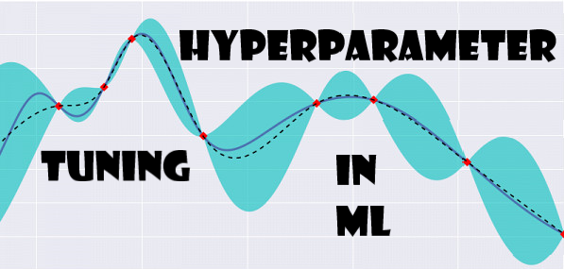

Certainly! Ensemble methods and hyperparameter tweaking may be effective ways for optimizing the performance of a machine learning model.

To increase prediction performance, ensemble approaches combine many models. Random Forests, Gradient Boosting, and AdaBoost are examples of common ensemble approaches. These strategies may aid in reducing overfitting and improving model resilience.

Hyperparameter tuning is crucial for finding the best set of hyperparameters that govern a model's behavior. Techniques like grid search or random search can be employed to systematically explore different combinations of hyperparameters and identify the ones that yield the best results.

If you have a specific model or dataset in mind, please share additional information so that I can provide more targeted guidance on how to approach ensemble techniques and hyperparameter tweaking in your unique scenario

**STEPS TO PERFORM HYPERPARAMETER TUNING:**

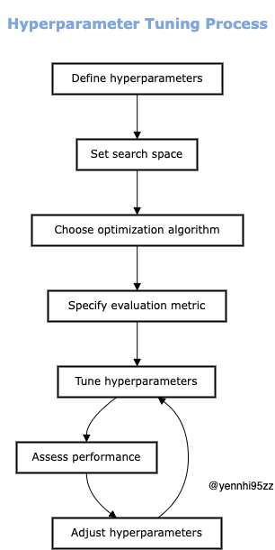

1. **SELECT HYPERPARAMETERS TO TUNE:** Different algorithms have different hyperparameters. Determining the correct ones for the chosen algorithm is the first step.
2. **CHOOSE A SEARCH SPACE**: This is the range of values each hyperparameter can take. The larger the search space, the more options the match will consider.
3. **OPTIMIZATION TECHNIQUES**: There are several techniques available, each with its own approach. Including:

* **Manual Search**: Manually try different hyperparameter values. Simple, but time consuming.
* **Random Search**: Random samples from the search space. Efficient, but may miss optimal values.
* **Grid Search**: Systematically explore all possible combinations. Complete, but computationally expensive.
* **Bayesian Optimization**: Use previous reviews to make informed decisions about where to look next. Efficient and effective.
* **Genetic Algorithms** : Inspired by natural selection, better sets of hyperparameters evolve over generations.

4**. EVALUATE PERFORMANCE**: For each set of hyperparameters, measure the model’s performance on the validation dataset using metrics such as accuracy, precision, or recall.

5**. SELECT BEST HYPERPARAMETERS**: Choose the set of hyperparameters that lead to the best model performance.

**INFLUENCE OF HYPERPARAMETERS ON MODELS:**

Before a performance, visualize a symphony orchestra tuning its instruments. Hyperparameters function similarly to how each instrument's tuning impacts the overall harmony when fine-tuning a machine learning model. Inaccurate hyperparameters can make a model difficult to play, just like an out-of-tune violin can ruin the tone.

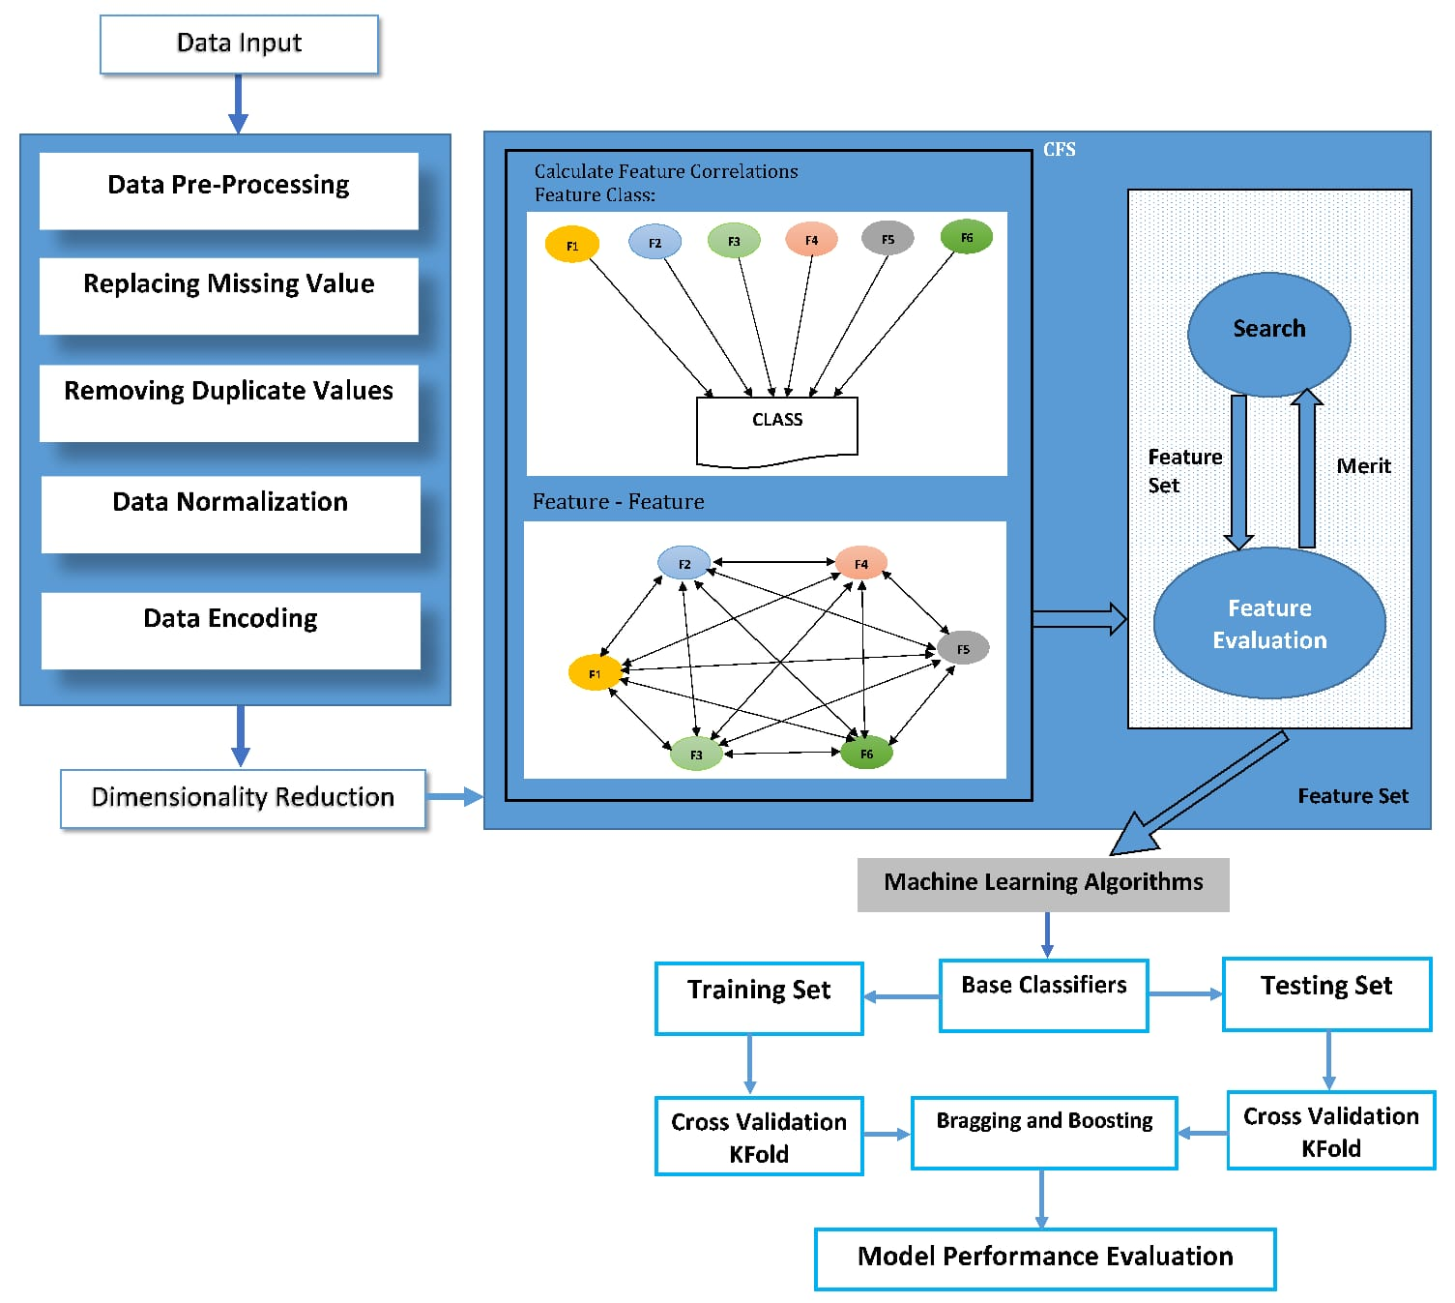

Let’s take a closer look at some essential hyperparameters and their influence on shaping the behavior of the model.

1. **TRAIN-TEST SPLIT ESTIMATOR:**

It's vital to talk about the first stage, the training-test split estimator, before delving into the area of machine learning-specific hyperparameters. Although this is not a hyperparameter in the conventional sense, it has an impact on how the model learns. We need data to train a model and data to verify its effectiveness when we are training a model. We divide our dataset into these two halves with the aid of the training test split estimator.

For example using the train_test_split function, for instance, we could divide our data into 60% for training and 40% for testing. Consistency in model evaluation is supported by the random_state parameter's guarantee that the same set of data is consistently generated. Without this control, evaluating a model can turn into a challenging puzzle, and neglecting the random state might cause the model to behave in an unanticipated way. In essence, random_state acts as the random number generator's seed, stabilizing the model's behavior.

from sklearn.model_selection import train_test_split

X_train, X_test, y_train, y_test = train_test_split(X, y, test_size=0.4, random_state=0)

1. **LOGISTIC REGRESSION CLASSIFIER:**

When we’re talking about classifying things, one common go-to is the Logistic Regression Classifier. Inside its workings, there’s a special knob called C, and it’s connected to something called the ‘regularization parameter,’ let’s call it λ (that’s a Greek letter “lambda”).

Now picture it as adjusting the brake and gas pedals on an automobile. Increasing C is equivalent to depressing the gas pedal more firmly while easing up on the brake. This 'C' aids in regulating how closely the model should resemble the data. If C is turned up too high, the model may overfit the data by memorizing it too thoroughly, but if C is kept low, the model may underfit the data by failing to recognize its patterns. Finding the ideal Ci is comparable to finding the ideal balance between safe driving and driving quickly.

Mathematically: C = 1/λ

from sklearn.linear_model import LogisticRegression

logreg = LogisticRegression(C=1000.0, random_state=0)

1. **K-NEAREST NEIGHBOR(KNN)CLASSIFIER:**

Choosing the ideal number of neighbors and the power parameter p are key components of the KNN algorithm. How many data points are taken into account while making predictions is controlled by the n_neighbors option. The p parameter also affects the distance metric that is used to determine the neighbors. The Manhattan distance is utilized when p = 1, and the Euclidean distance is used when p = 2.

Mathematically:

* For p = 1: Manhattan Distance
* For p = 2: Euclidean Distance

from sklearn.neighbors import KNeighborsClassifier

knn = KNeighborsClassifier(n_neighbors=5, p=2, metric='minkowski')

These are just a few examples of how hyperparameters can shape the behavior of a machine learning model

**PYTHON PROGRAM:**

Certainly! Here's a Python program that demonstrates how to use ensemble methods (Random Forest) and hyperparameter tuning (Grid Search) using the popular scikit-learn library:

python

# Import necessary libraries

import numpy as np

import pandas as pd

from sklearn.datasets import load_iris

from sklearn.model_selection import train_test_split

from sklearn.ensemble import RandomForestClassifier

from sklearn.model_selection import GridSearchCV

# Load a sample dataset (you can replace this with your own dataset)

data = load_iris()

X = data.data

y = data.target

# Split the dataset into training and testing sets

X_train, X_test, y_train, y_test = train_test_split(X, y, test_size=0.2, random_state=42)

# Create a Random Forest Classifier

rf_classifier = RandomForestClassifier()

# Define a parameter grid to search through

param_grid = {

'n_estimators': [10, 50, 100, 200], # Number of trees in the forest

'max_depth': [None, 10, 20, 30], # Maximum depth of the trees

'min_samples_split': [2, 5, 10], # Minimum samples required to split an internal node

'min_samples_leaf': [1, 2, 4] # Minimum number of samples required to be at a leaf node

}

# Create a GridSearchCV object to find the best hyperparameters

grid_search = GridSearchCV(estimator=rf_classifier, param_grid=param_grid, cv=5)

# Fit the grid search to the training data

grid_search.fit(X_train, y_train)

# Get the best parameters and best estimator

best_params = grid_search.best_params_

best_estimator = grid_search.best_estimator_

# Print the best parameters

print("Best Hyperparameters:")

print(best_params)

# Evaluate the model on the test data

accuracy = best_estimator.score(X_test, y_test)

print(f"Accuracy on Test Data: {accuracy:.2f}")

This code uses the Iris dataset as an example, but you can replace it with your own dataset. It first creates a Random Forest Classifier, then uses GridSearchCV to search for the best hyperparameters. Finally, it evaluates the model's accuracy on the test data. Remember to install scikit-learn (`pip install scikit-learn`) if you haven't already.

**CONCLUSION:**

Hyperparameter tuning may seem like a complicated puzzle, but it is a puzzle worth solving. By finding the right combination of hyperparameters, you can turn a trivial machine learning model into a powerful tool for making accurate predictions. As you begin your machine learning journey, remember that hyperparameter tuning is an essential skill in your toolkit, one that can take your models from good to great.